 

|  |
| --- |
| **FPT- APTECH COMPUTER EDUCATION** |
| eProject Report |
| Team 3 |
|  |
| |  |  | | --- | --- | | **Team 3** | | | **Group Member** | Nguyễn Xuân Trường  Đặng Thị Thu Hà  Trần Công Vũ  Nguyễn Chí Công  Vũ Trường | | **Batch** | Bot work | | **Center** | FPT APTECH HN | | **Semester** | 4 | |
|  |

*<Remember to update the table of contents>*

**Contents**

1. Acknowledgements 4

2. Introduction 4

3. Problem Definition 4

3.1. Problem Abstraction 4

3.2. The Current System 4

3.3. The Proposed System 4

3.4. Boundaries of the System 4

3.5. Development Environment 4

4. Requirements and Business Flows 5

4.1. Customer Requirements 5

4.2. Activity Diagram(Optional) 5

4.3. Use Case Diagram 5

4.4. Use Case Specification (optional) 5

4.5. Other Concerns<Optional> 6

5. Design 7

5.1. System Architecture 7

5.2. Class Diagram 7

5.3. Class Diagram Explanation 7

5.4. Sequence Diagram 7

5.5. Collaboration Diagram (Optional) 7

5.6. State Diagram (Optional) 7

5.7. Entity Relationship Diagram 7

5.8. Database Design 7

5.9. Algorithms (optional) 8

5.10. Others (optional) 8

6. System Prototype 9

6. Management and Project Planning 10

6.1. Management Approach 10

6.2. Project Plan 10

6.3. Task Sheet 10

6.4. Meeting Minutes (Optional) 10

7. Checklists 11

7.1. Check List of Validation 11

7.2. Submission Checklist 11

8. Screenshots 11

9. Coding Convention 11

10. User Guide 12

11. Other Concerns<Optional> 13

Appendix 14

Glossary [Optional] 14

References [Optional] 14

Others<Optional> 14

# Acknowledgements

# Introduction

*+ Bot cv is an online recruitment platform that helps find jobs in the digital age.*

*+ Helping students and employees wishing to change jobs or find a new environment that suits themselves.*

*+Make it easy for employers of companies to find suitable candidates for their companies*

# Problem Definition

## Problem Abstraction

*+There are 3 types of account (admin, recruitment, candidate).*

*+Admin: The website manager, managing everything related to information of employers and candidates.*

*+Recruitment: An employer is the person who posts recruiting articles and jobs on the website in order to find suitable candidates.*

*+Candidate: Candidates are those in need of finding a stable, good job through posts and job vacancies to develop themselves as a stable source of income.*

## The Current System

*The system is managed by many users, ensuring stability.*

## The Proposed System

*The system is written in the C # programming language over a cross-platform dotnet platform and uses Postgres DB*

## Boundaries of the System

*There is no function of payment via visa card*

## Development Environment

*backend: C # dotnet core + postgres*

*frontend: ReactJs*

# Requirements and Business Flows

* *admin :*
* *Filter verify candidates*
* *Employer account management (in progress)*
* *Candidate account management*
* *Post news articles*
* *Recruiment :*
* *Post recruitment articles to find candidates*
* *Post new news.*
* *Log in to the system.*
* *Receive application notification from candidates*
* *Accept the application request, the candidate will be added to the Job.*
* *Search for suitable candidates (in progress)*
* *Candidate :*
* *See available Jobs that employers have posted*
* *See job details*
* *Apply for a job that suits you*

## Customer Requirements

* *Admin wants to manage multiple accounts and calculate revenue per day.*

## Activity Diagram

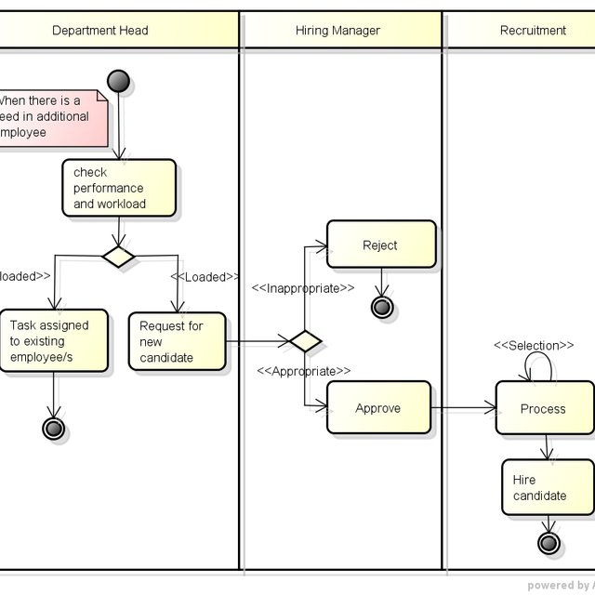

## Use Case Diagram

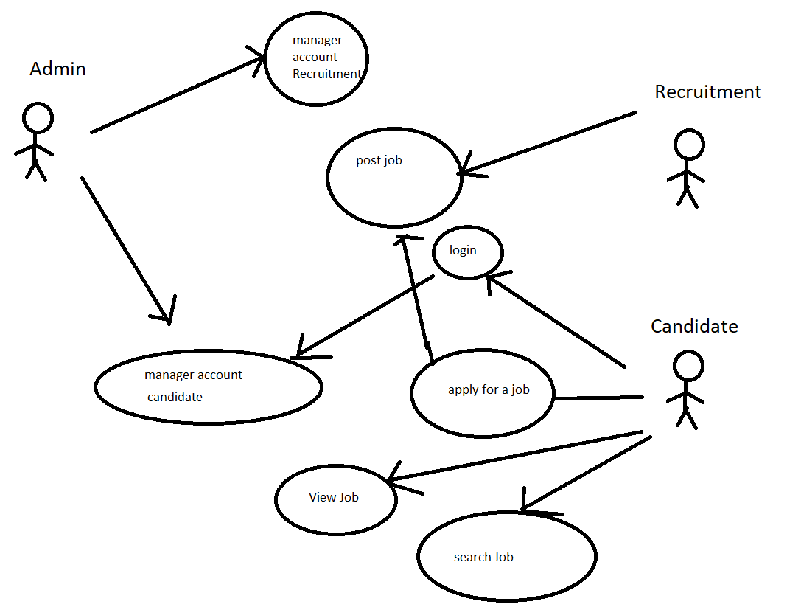

## Use Case Specification (optional)

*<Write down all non-trivial use cases. This should reflect what you get when your team does the system analysis. Use the template to write the detailed specification for use cases>*

*<Use case temlpate:*

|  |  |  |  |  |
| --- | --- | --- | --- | --- |
| **USE CASE SPECIFICATION** | | | | |
| **Use-case No.** | <UC001> | **Use-case Version** | | <1.0> |
| **Use-case Name** | <Name> | | | |
| **Author** | <Members> | | | |
| **Date** | Dd/mm/yyyy | **Priority** | <High\Normal\Low> | |
| **Actor:**  <Lit all actors>  **Summary:**  *<Briefly describe the use case>*  **Goal:**  *<Briefly describe the goal of use case>*  **Triggers**  *<What leads this use case?>*  **Preconditions:**  *<List the required pre-conditions for this use case>*  **Post Conditions:**  *<List the required post-condition for this use case>*  **Main Success Scenario:**  *<List the main steps for this use case to reach the goal successfully >*    **Alternative Scenario:**  *<List the other steps for this use case to reach the goal in some alternatives condition >*  **Exceptions:**  *<list the exceptions of this use case>*  **Relationships:**  *<List the relationships that use case relates to>*  **Business Rules:**  *<Any concern about the business>* | | | | |

## Other Concerns<Optional>

*<You can list here all other concerns about the business or the requirements if needed>*

# Design

* Home page

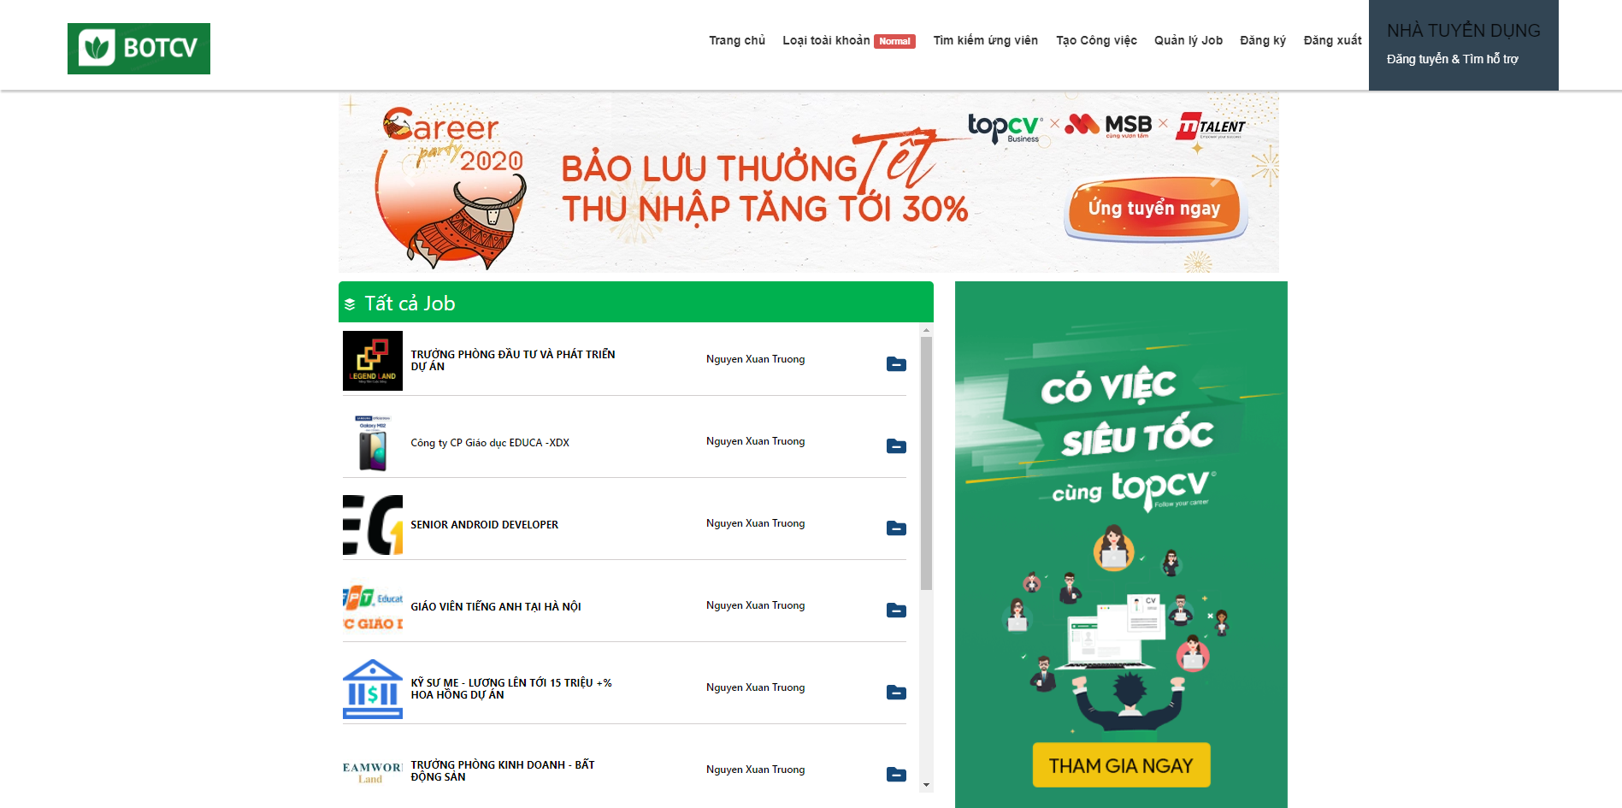

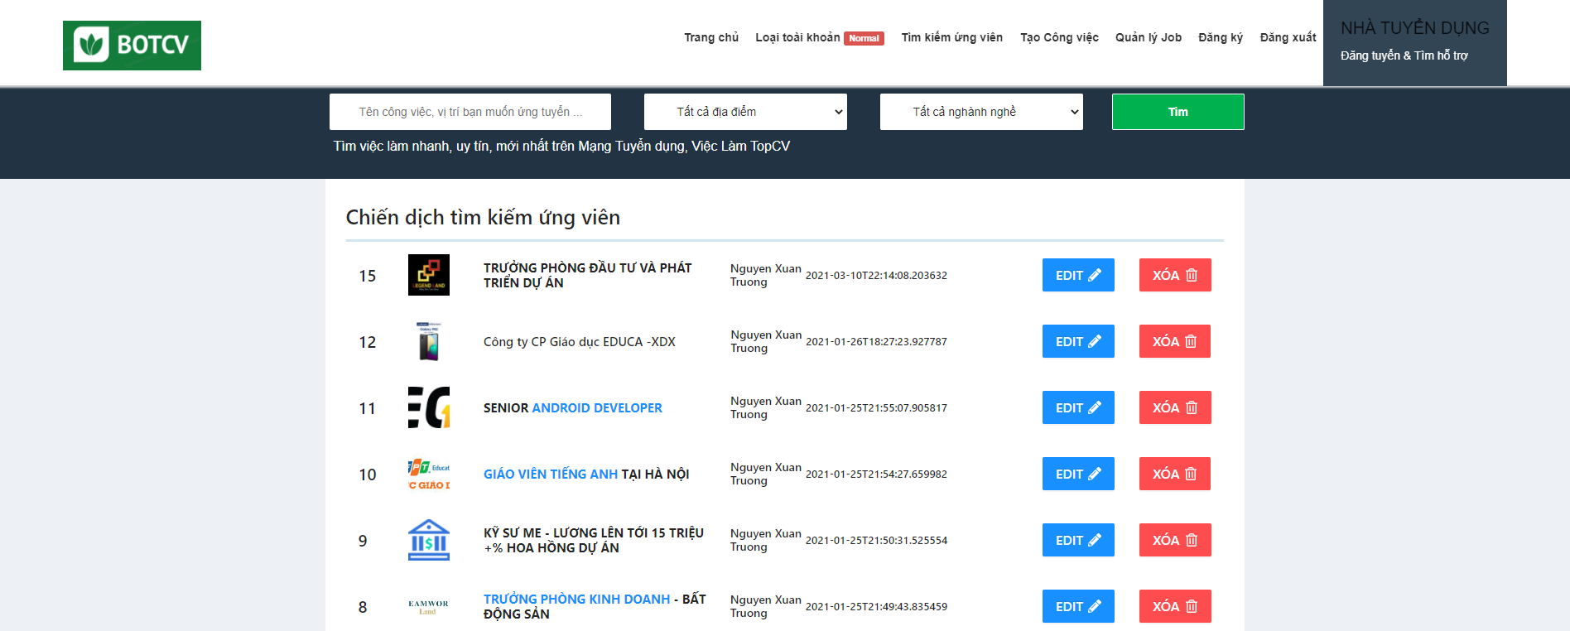

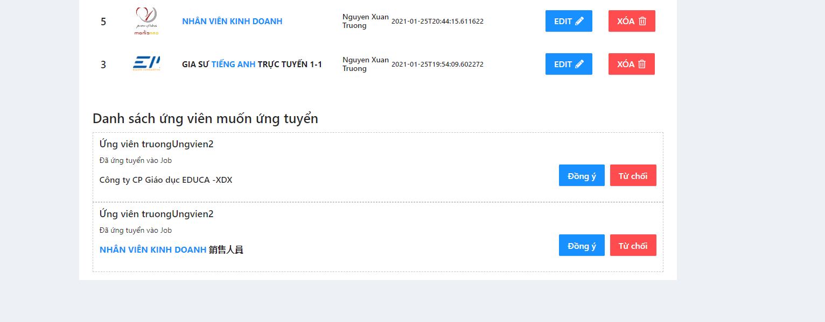

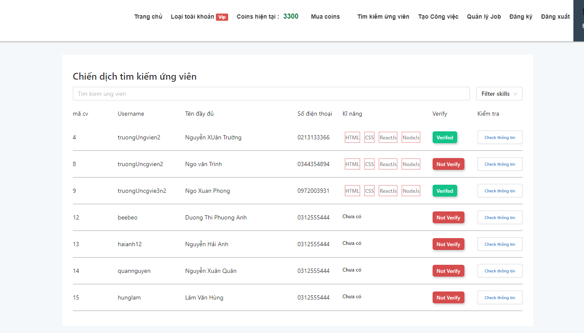

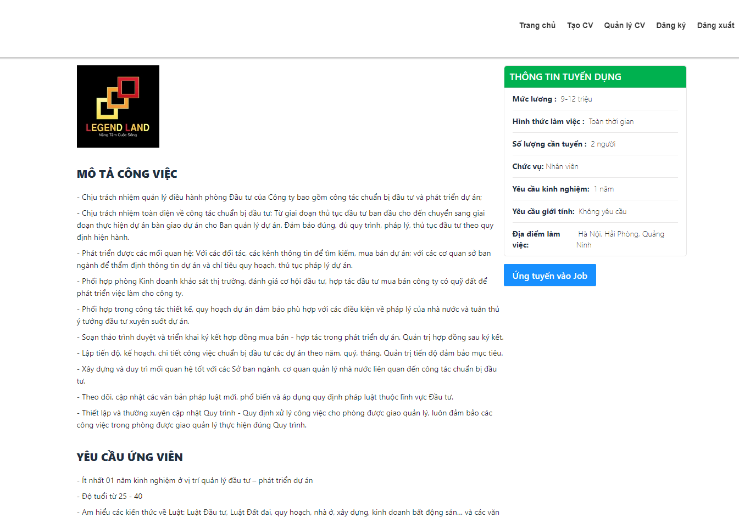

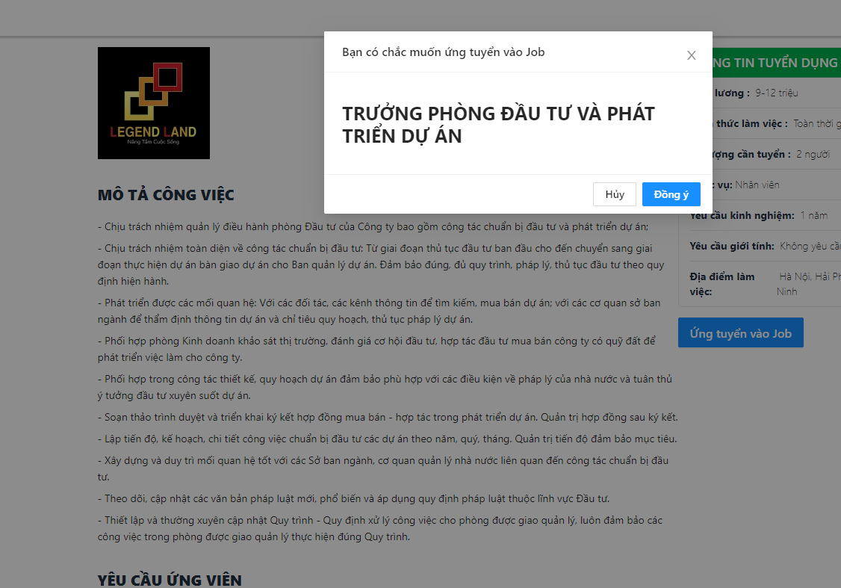

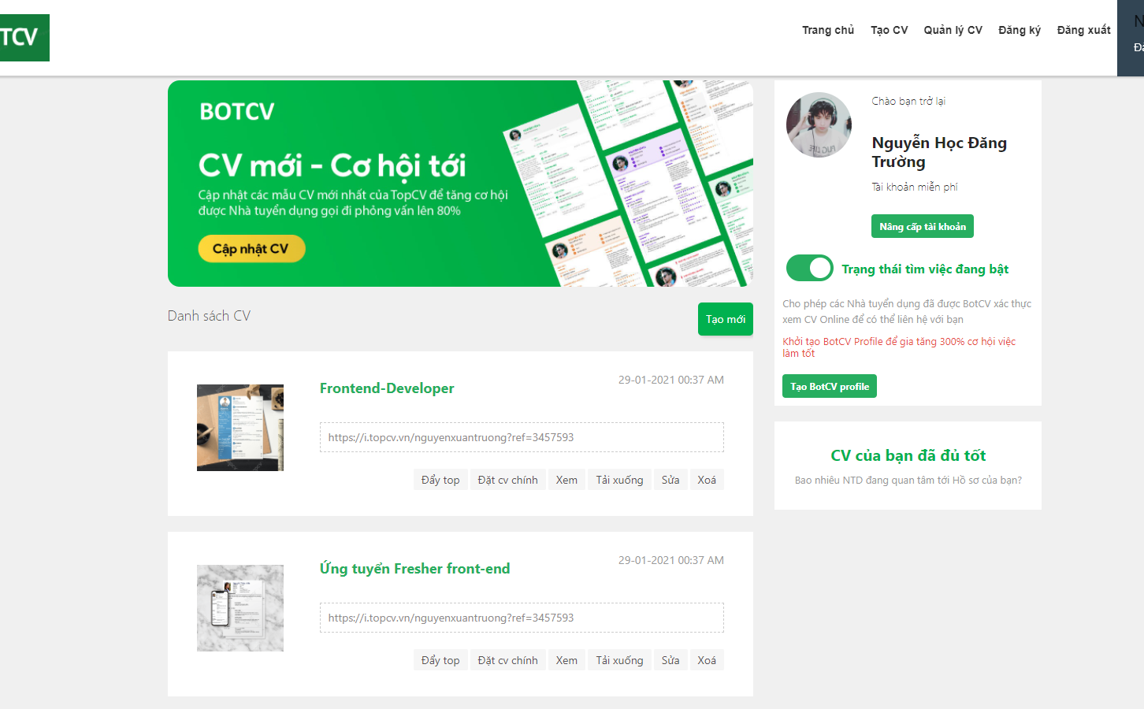

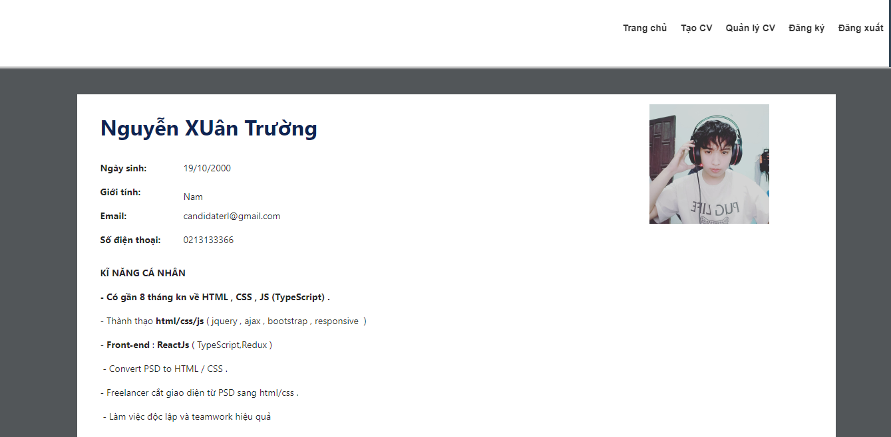

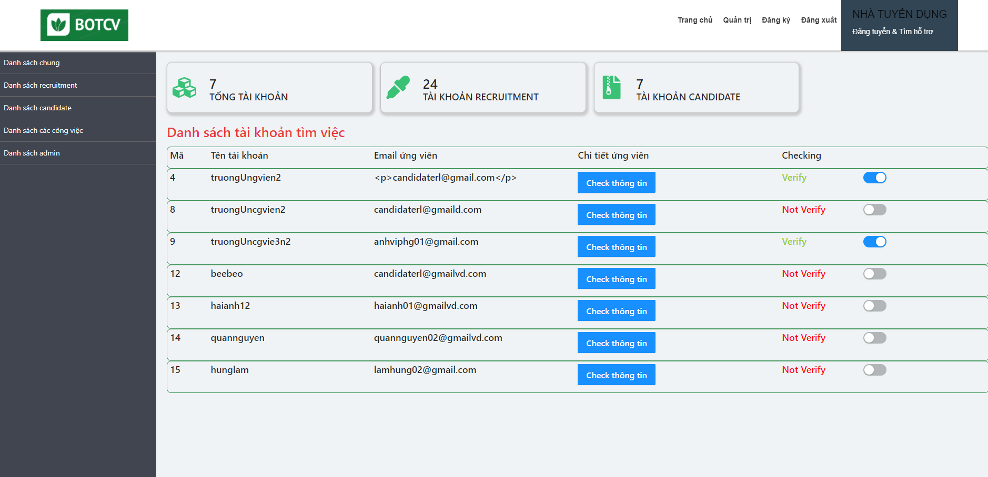

## System Architecture

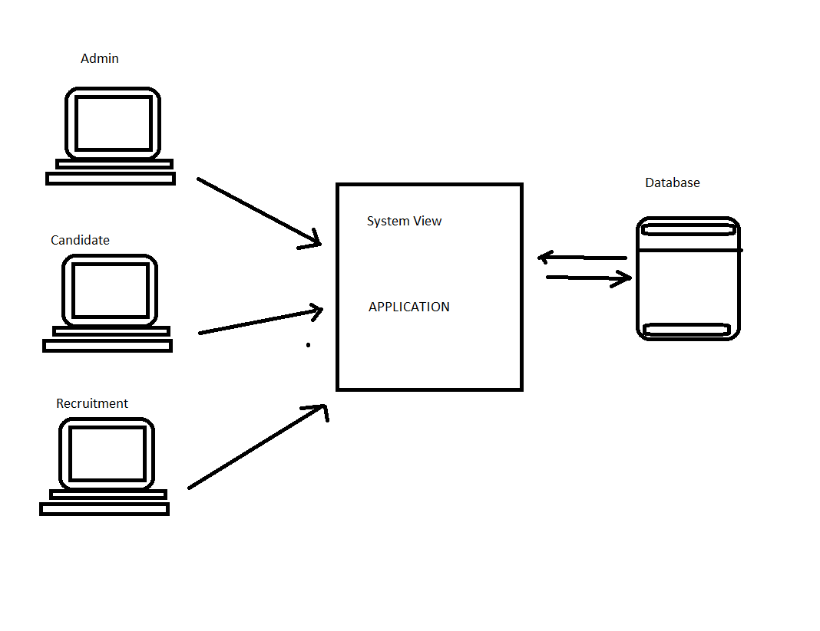

## Class Diagram

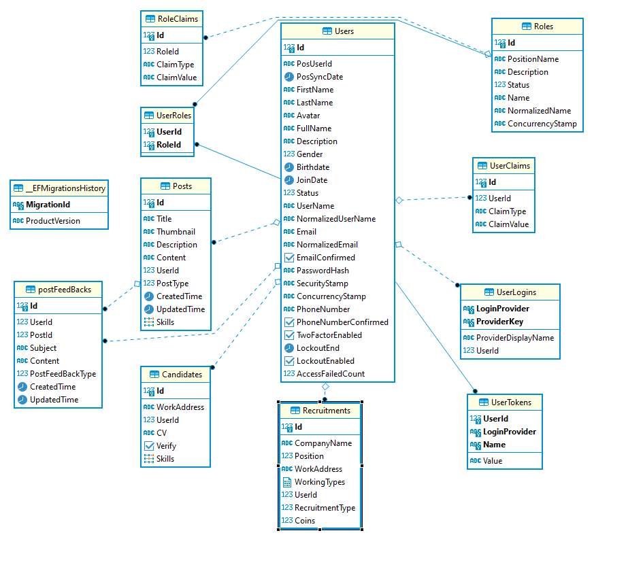

## Class Diagram Explanation

* *UserLogin : login account*
* *postFeedBacks: recruitment to receive candidate recruitment notices*
* *Post : Manage recruitment posts*
* *Users:Manage candidate list*
* *Roles: Decentralize login system*
* *Recruitments: Management of the recruitment list*
* *Candidates: Management of the candidate list*

## Sequence Diagram (Optional)

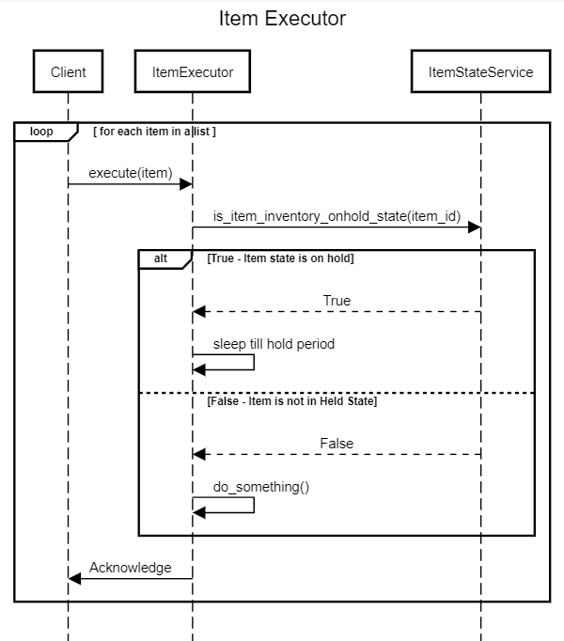

## Collaboration Diagram (Optional)

## State Diagram (Optional)

## Entity Relationship Diagram

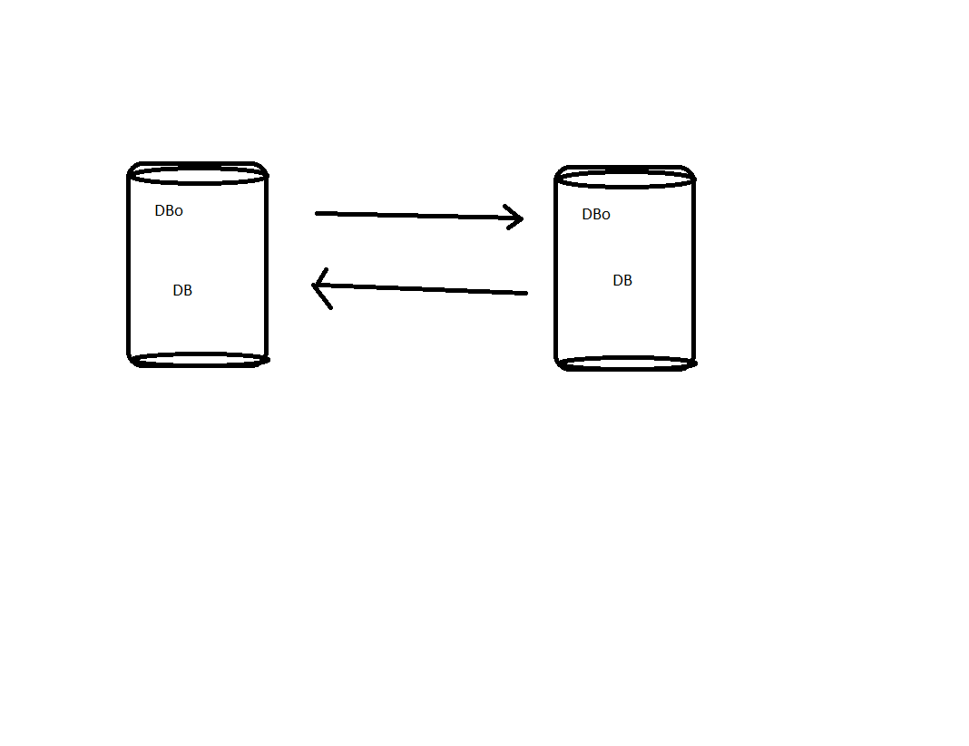

## Database Design

**

## Algorithms (optional)

*Not available*

## Others (optional)

*Not available*

# System Prototype

# Management and Project Planning

## Management Approach

*- Management by github and teamwork with trello.*

## Project Plan

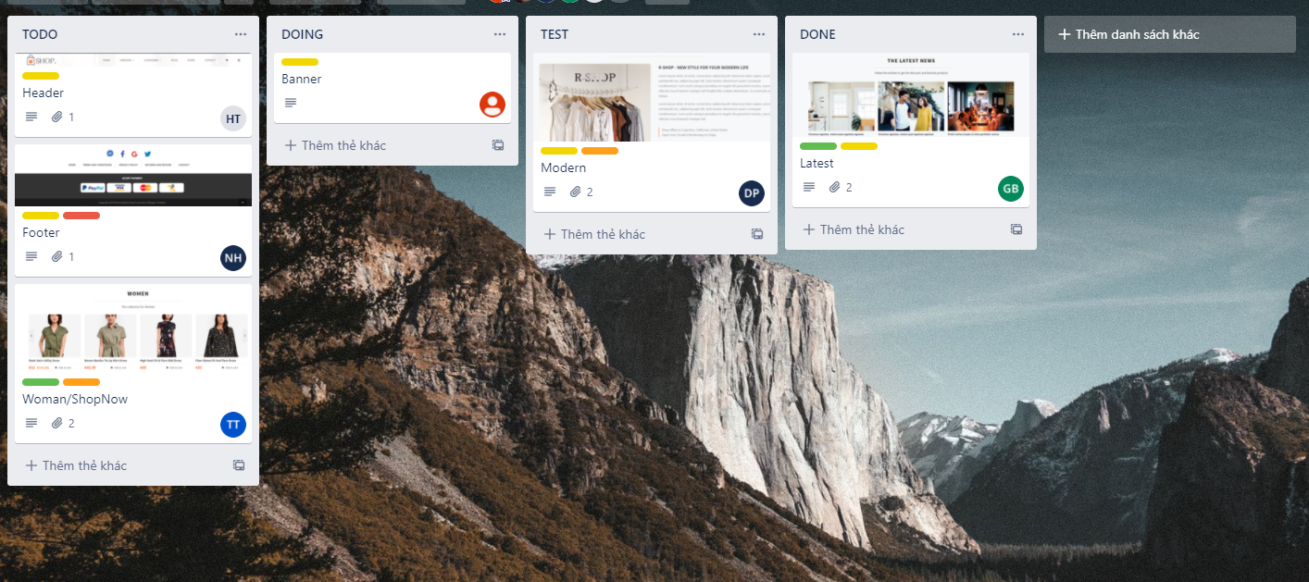

## Task Sheet

*- Complete login function.*

*- Complete the candidate's application function.*

*- Complete the job creation function.*

*- Complete the function of receiving employer notifications.*

*- Complete candidate search function.*

## Meeting Minutes (Optional)

* *Not available*

# Checklists

## Check List of Validation

*Not available*

## Submission Checklist

*Not available*

# Screenshots

1. 
2. 
3. 

# Coding Convention

* *Using Javascript Convention . Capitalization, BEM CSS HTML .*

# User Guide

* *Login or registration, then access table manager.*

# Other Concerns<Optional>

*- Lack of a few functions such as creating ads to increase income.*

*- Revenue report function by day, week, quarter.*

*- Post comment function.*

# Appendix

Not available

## Glossary [Optional]

*Not available*

## References [Optional]

Not available

## Others<Optional>

Not available